Create a Self-hosted Agent

In order to create a self-hosted agent, go to **Project Settings** and select the **Agent pools** option under the **Pipelines** section. Press the **Add pool** button and configure the agent:

* Select the **Pool type** as Self-hosted
* Add a descriptive pool **Name** (in this example my-personal-computer)
* Check the **Pipeline permissions** box so you do not need to grant permission manually
* Click on the **Create** button

[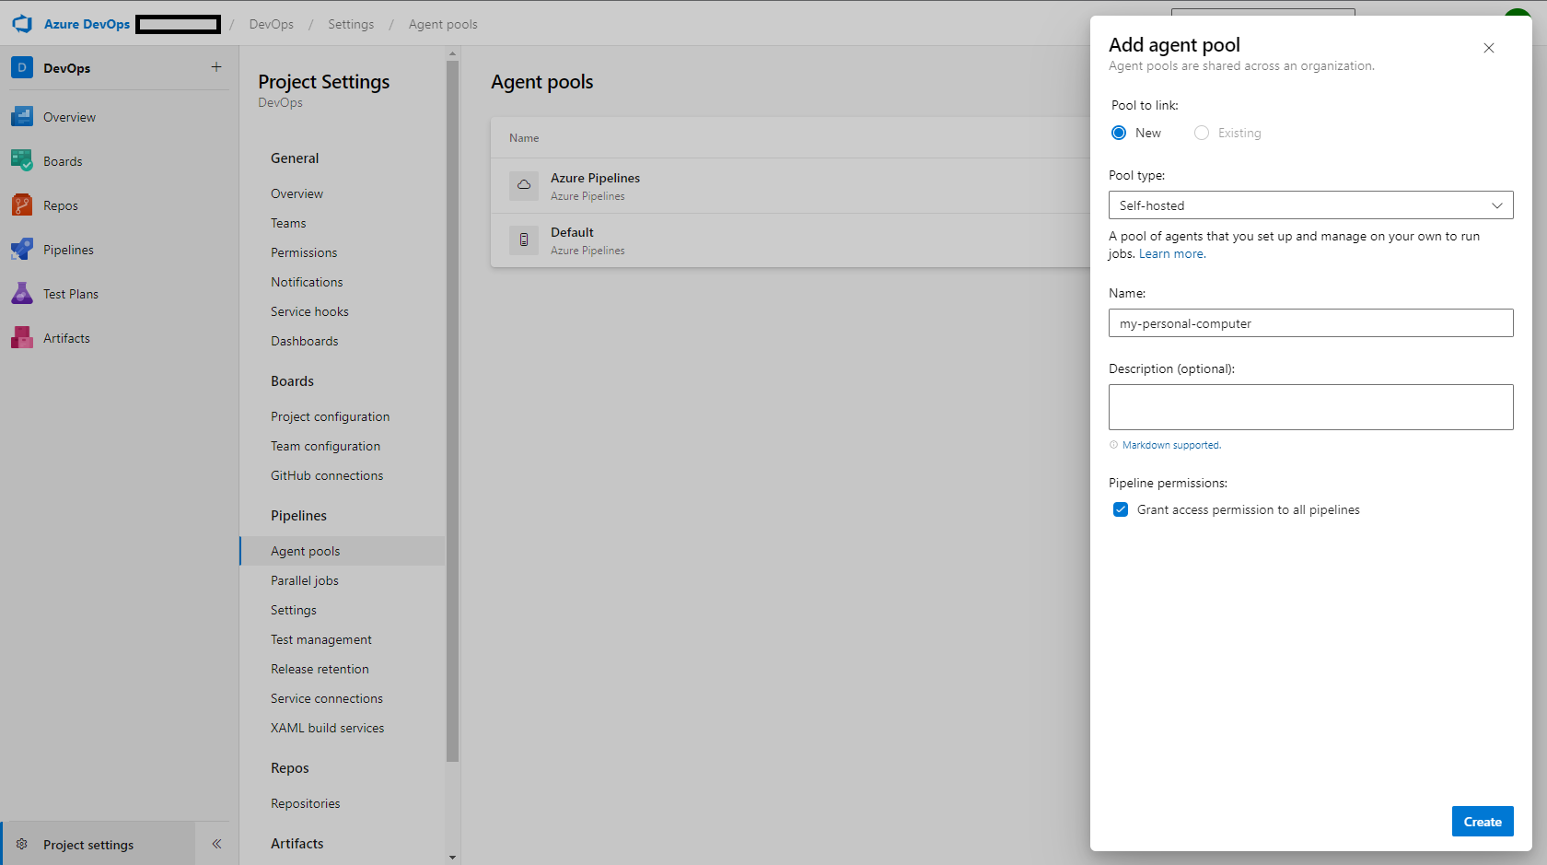](https://i.stack.imgur.com/pzlDS.png)

Now, navigate to the freshly created agent. On the top-right corner, press the **New Agent** button. You can create Windows, macOS, and Linux agents. Based on your computer select the appropriate OS then follow the instructions:

1. Extract the archive: Download the agent then extract it to a folder
2. Configure the agent: Run the config scripts and select the default settings:
   * Server URL: Copy and paste the organization URL which looks like the following https://dev.azure.com/<my-organization-name>
   * Personal Access Token (PAT): Go to the **Personal Access Tokens** option under the **User Settings** icon. Make sure that you generate a PAT which has **Read & manage** access to the Agent pools [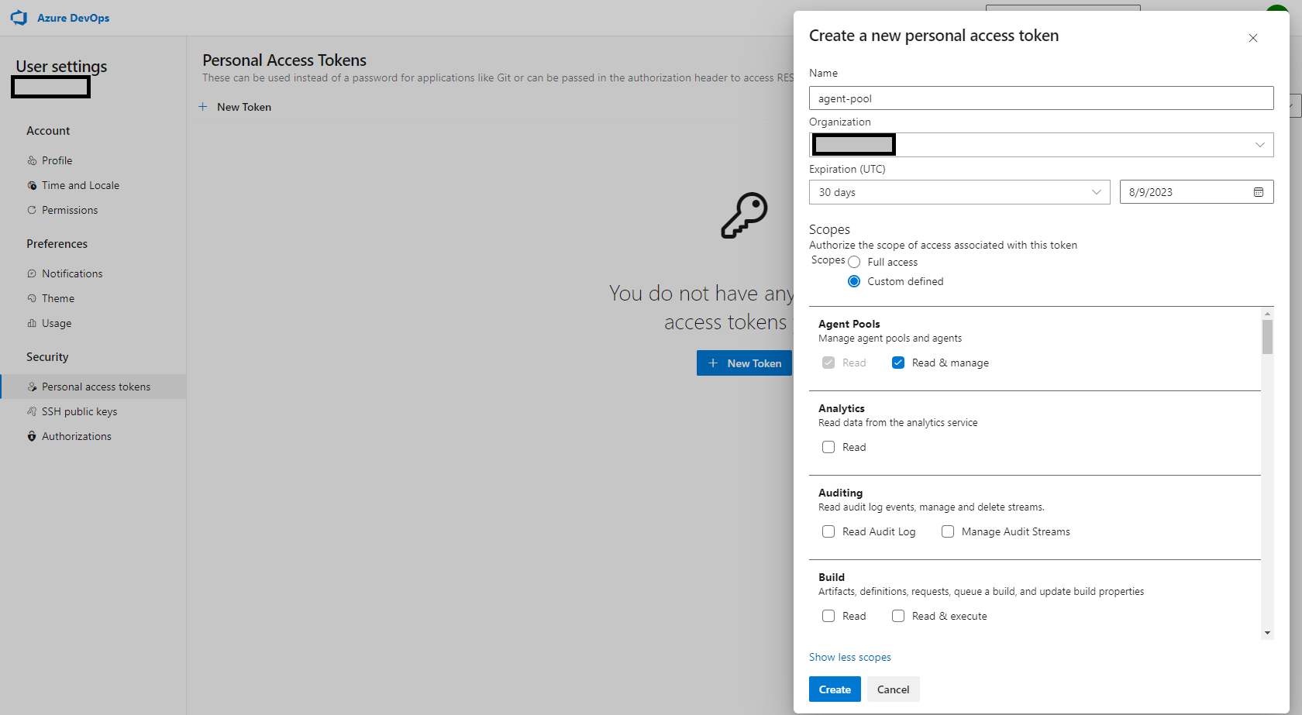](https://i.stack.imgur.com/3iy8d.png)
   * Agent pool name: The newly created pool which is the my-personal-computer in our case
   * Agent Name: Give a meaningful name (e.g Windows-Agent) or stay with the default
   * Work folder: Press enter for the default
   * Agent as Service: Press enter for the default
3. Run the agent: Execute the run script

Once it is done, you can see that the Agent is up and running under the **Agents** panel.

[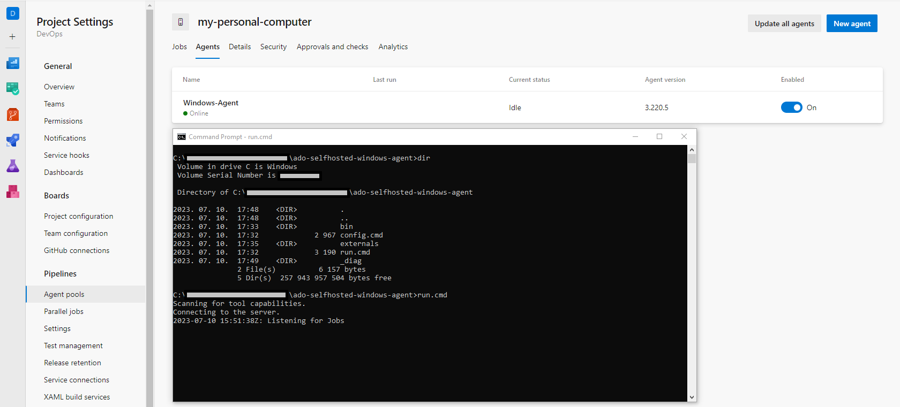](https://i.stack.imgur.com/lkMFJ.png)

The self-hosted agent is connected to Azure DevOps and listens for new jobs.

Note: If you create a service during the agent configuration then you do not need to run the agent manually.

Configure the Pipeline

The last step is to update the Pipeline to use the recently created agent. Go to the **Pipelines** and select your pipeline. Click on **Edit** and add the pool: <my-selfhosted-agent> section to the config file. Here is an azure-pipeline.yml file example:

trigger:

- main

pool: my-personal-computer

strategy:

matrix:

Python36:

python.version: '3.6'

Python37:

python.version: '3.7'

steps:

- task: UsePythonVersion@0

inputs:

versionSpec: '$(python.version)'

displayName: 'Use Python $(python.version)'

- script: |

python -m pip install --upgrade pip

pip install -r requirements.txt

displayName: 'Install dependencies'

- script: |

pip install pytest pytest-azurepipelines

pytest

displayName: 'pytest'

It will go to the pool and select an available agent. We have only one agent so it selects it and run the various jobs on it. You can go inside your self-hosted agent folder and get the logs from the _work directory. You can also view the output of the jobs on Azure DevOps.

References:

<https://stackoverflow.com/questions/68405027/how-to-resolve-no-hosted-parallelism-has-been-purchased-or-granted-in-free-tie>